**1. What is a Framework?**

Selenium framework is a code structure that is used to make code maintenance simpler and readability better. It helps in dividing the entire code into smaller parts of the code in a systematic way.

**2. Tell me some popular Test Automation Frameworks?**

* **Data-Driven Testing Framework**

While testing an automation framework, a series of tests need to be conducted before a successful outcome is derived. You might need to change the test data in such cases to try arriving at a different conclusion. The Data-Driven Testing Framework allows you the freedom to store the test data in an external drive, which can be accessed later to add a new script to the test case.

* **Keyword-Driven Testing Framework**

Usually considered to be an extension of the data-driven testing framework, the keyword-driven testing framework not only extracts your test data to an external source but also maintains the set of codes safely. These codes are also referred to as ‘keywords’ and can be used to alter the test script to conclude further possible outcomes from the test framework. These keywords also essentially decide the functions performed by every application.

* **Hybrid Testing Framework**

The hybrid testing framework combines the data-driven and keyword-driven frameworks to execute the most out of the aforementioned frameworks. It is the most ideal automation framework, allowing more scope for increased productivity and a better success rate.

* **Linear Scripting Framework**

Unlike the above, Linear Scripting is carried out manually by an individual who records each and every step of the process. This framework is also known as the Record and Playback framework and takes up ample time to execute. It does not rely on automation expertise and might be a simple way to record a script, but it does not leave any space of script reuse. It also takes time for maintenance and you would have to hand-code the test script in order to run the framework in the future.

* **Module Based Testing Framework**

As the name suggests, the Module Based Testing Framework requires the existence of various modules to run the framework. You would have to create separate scripts for every module and collaborate them in order to generate the best results out of the automation test. If variations are made in how the application works, the modules would not be affected. The scripts remain unharmed until one manually alters them. This offers a cost-efficient method of management since the combination of several modules creates a high level of modularization. The productivity remains at its peak. However, much time and effort can go into individually making changes to the test data in case there is a need.

**3. Why Framework?**

**Frameworks are about efficiency and effectiveness**. They save you time. By forcing common conventions, a framework helps solve common issues like view rendering, asset generation, security, application configurations -- things that happen in every web application.

**4. Have you created any Framework?**

Yes.

**5. What are the advantages of using Test Automation Framework?**

**Benefits of a Test Automation Framework**

* Improved test efficiency.
* Lower maintenance costs.
* Minimal manual intervention.
* Maximum test coverage.
* Reusability of code.

**6. Which Test Automation Framework you are using and why?**

I am using Hybrid framework test automation framework Using frameworks leads to increased code reusability, higher portability, reduced cost of script maintenance, better code readability, etc. The Hybrid framework offers these advantages by functioning as a combination of both Keyword and Data-Driven framework.

**7. Mention the name of the framework which ‘you are currently using’ or which ‘you have hands on experience’**

I am using Hybrid framework test automation framework

**8. Can you explain the Framework which you have used in your Selenium Project?**

        





**9. Where have you applied OOPs in your Automation Framework?**

ABSTRACTION

In Page Object Model design pattern, we write locators (such as id, name, xpath etc.,) in a Page Class. We utilize these locators in tests but we can’t see these locators in the tests. Literally we hide the locators from the tests. Abstraction is the methodology of hiding the implementation of internal details and showing the functionality to the users.

INTERFACE

Basic statement we all know in Selenium is WebDriver driver = new FirefoxDriver();

WebDriver itself is an Interface. So based on the above statement WebDriver driver = new FirefoxDriver();

We are initializing Firefox browser using Selenium WebDriver. It means we are creating a reference variable (driver) of the interface (WebDriver) and creating an Object. Here WebDriver is an Interface as mentioned earlier and FirefoxDriver is a class. An interface in Java looks similar to a class but both the interface and class are two different concepts. An interface can have methods and variables like the class but the methods declared in interface are by default abstract. We can achieve 100% abstraction and multiple inheritances in Java with Interface.

INHERITANCE

We create a Base Class in the Framework to initialize WebDriver interface, WebDriver waits, Property files, Excels, etc., in the Base Class. We extend the Base Class in other classes such as Tests and Utility Class. Extending one class into other class is known as Inheritance.

POLYMORPHISM

Combination of overloading and overriding is known as Polymorphism. We will see both overloading and overriding below. Polymorphism allows us to perform a task in multiple ways.

METHOD OVERLOADING

We use implicit wait in Selenium. Implicit wait is an example of overloading. In Implicit wait we use different time stamps such as SECONDS, MINUTES, HOURS etc., A class having multiple methods with same name but different parameters is called Method Overloading

METHOD OVERRIDING

We use a method which was already implemented in another class by changing its parameters. To understand this you need to understand Overriding in Java. Declaring a method in child class which is already present in the parent class is called Method Overriding. Different drivers Examples are getting and navigate methods of in Selenium.

ENCAPSULATION

All the classes in a framework are an example of Encapsulation. In POM classes, we declare the data members using @FindBy and initialization of data members will be done using Constructor to utilize those in methods. Encapsulation is a mechanism of binding code and data together in a single unit. I would like to discuss some other topics which we use in Automation Framework.

WEB ELEMENT:

Web element is an interface used to identify the elements in a web page. WEBDRIVER: WebDriver is an interface used to launch different browsers such as Firefox, Chrome, Internet Explorer, Safari etc.,

FIND BY: FindBy is an annotation used in Page Object Model the elements.

FIND ELEMENT: design pattern to identify Find Element is a method in POM to identify the elements in a web page.

**10.What is Automation testing? What are the advantages of Automation Testing?**

Automation testing mainly focuses on reducing manual human activity with devices or systems. It **increases the efficiency, effectiveness, and coverage of software testing.** **It saves time and effort**.

Saves time

Automating the testing process helps the testing team to use less time to validate newly created features. For instance, in manual testing, there is a need to write thousand test cases for a calculator application, but automation makes the process much faster.

Productivity improvement

As during execution, automation tests do not require human intervention, so testing an application can be done late at night, and we can get the results next morning. Software developers and testers require less time on automation testing.

Accuracy improvement

In manual testing, there is a chance of mistakes whether you are an experienced testing engineer. The chances of errors may increase when testing a complex use case. But Automation testing reduces the chances of errors. There is good accuracy, as we will get the same result each time on performing the same test cases.

Test suite reusability

We can reuse the test scripts in automation testing, and we don't need to write the new test scripts again and again. These test cases can be used in various ways, as they are reusable. Reusability helps to reduce the cost and also eliminate the chances of human error.

Ability to test on various platforms

Automation testing allows the user to test the application on different web browsers and operating systems.

Running tests 24/7

In automation testing, we can start the testing process from anywhere in the world and anytime we want. It can also be done remotely if we don't have many approaches or the option to purchase them.

Early bug detection

By automation testing, it is easy to detect critical bugs in the initial phases of software development. It reduces the cost and helps us to spend fewer working hours to fix such problems. It increases the efficiency of the team.

Less human resources

Automation testing requires fewer people to perform a tedious manual test. To implement the automation test script, we need a test automation engineer who can write the test scripts to automate our tests.

Reduce the expenses

Automation testing is less expensive, as once the test scripts have been built, we can reuse them at any time without any extra cost. While manual testing is more expensive than automation, with manual monitoring, it is typical to execute experiments repeatedly.

Scalability of test cases

In manual testing, we require the involvement of the number of people and number of hours to scale up a project. Whereas the scalability of automation testing is higher, we need adding of test executors to the testing framework.

Consistency

Compared to manual testing, automation testing is more consistent and way faster than executing the regular monotonous tests that cannot be missed but may cause faults when tested manually.

**11.What are the most popular testing tools for functional testing?**

* UFT. Unified Functional Testing (UFT) is a well-known commercial testing tool for functional testing. ...
* Tricentis Tosca. ...
* Sauce Labs. ...
* TestComplete. ...
* Selenium. ...
* Worksoft Certify. ...
* Micro Focus LeanFT. ...
* Parasoft SOAtest.

**12.Why do you prefer Selenium Automation Tool?**

1. Language and Framework Support

When someone chooses a tool the first thing that comes to mind is: "Does my tool supports the language that I know?"

Well, this is not the case with Selenium as it supports all major languages like Java, Python, JavaScript, C#, Ruby, and Perl programming languages for software test automation.

You can write your scripts in any of these programming languages and Selenium converts it into Selenium compatible codes in no time. So, there is no need for knowing Selenium only languages. Also, every Selenium supported language has dedicated frameworks which help in writing test script for Selenium test automation. So, when you go for Selenium as a tool for performing automation testing, you don’t have to worry about language and framework support as Selenium does that for you!

## 2. Open Source Availability

One of the many things that adds to the advantages of Selenium is its open source availability. So, being an open source tool, Selenium is a publicly accessible automation framework and is free, with no upfront costs. So, you can save bucks here and use them for other good causes.

The Selenium community is continuously helping developers and software engineers in automating the web browser features and functionalities. Selenium being open source also helps you customize the code for better code management and enhance the functionality of predefined functions and classes. Selenium has become the most reliable web automation tool because of the ease of generating test scripts to validate functionality.

## 3. Multi-Browser Support

“One Selenium script for all browsers” is what the Selenium community has been working on and improvising every day. As per [StatCounter](http://gs.statcounter.com/browser-market-share), Chrome, Firefox, Safari, Internet Explorer, Opera, and Edge browsers are the most used browsers worldwide and Selenium script is compatible with all the mentioned browsers. You don’t need to rewrite scripts for every browser, just one script for all browsers.

## 4. Support Across Various Operating Systems

Different people use different operating systems and it is necessary that your automation tool supports all of them. Selenium is yet a highly portable tool that supports and can work across different operating systems like Windows, Linux, Mac OS, UNIX, etc.

You can create Selenium test suites over any platform like Windows and can execute the same test suite on another platform, for example, Mac or Linux. This enables developers and software testers to easily write test automation scripts without laying much emphasis on the platform on which it will run.

## 5. Ease Of Implementation

Selenium automation framework is very easy-to-use tool. Selenium provides a user-friendly interface that helps create and execute test scripts easily and effectively. You can also watch while tests are running. You can analyze detailed reports of Selenium tests and take follow-up actions.

And finally, you will never feel alone. A huge Selenium community is always available to help you in case of need. You can ask your queries and perform brainstorming in the community.

## 6. Reusability and Integrations

As mentioned earlier, Selenium automation test suites are reusable and can be tested across multiple browsers and operating systems. However, the twist is if that Selenium is not an all-inclusive web automation testing tool. Hence, it needs third-party frameworks and add-ons to broaden the scope of testing.

For example, you need to integrate Selenium with [TestNG](https://testng.org/)and [JUnit](https://junit.org/junit5/)for managing test cases and generating reports. For achieving continuous testing, you’ll need to integrate it with some CI/CD tools like [Jenkins](https://jenkins.io/), Maven, and Docker. Also, for performing image-based testing, you need to integrate Selenium with tools like Sikuli, and for performing cross-browser testing with cloud-grid. You can integrate Selenium with almost all management tools.

## 7. Flexibility

Test management is what which is very important in testing lifecycle. It becomes easier and more efficient with Selenium features like regrouping and refactoring of test cases. This helps developers and testers in quick changes to the code, reducing duplication, minimizing complications and improving maintainability. These features make Selenium more flexible and usable as compared to other automation testing tools and hence helps Selenium to keep an edge.

## 8. Parallel Test Execution and Faster Go-to-Market

The main aim of automated testing is to save time and efforts. With the help of Selenium Grid, we can execute multiple tests in parallel, hence reducing the test execution time. With the help of cloud-grids for cross-browser testing you can test across as many as hundreds of browsers in parallel using Selenium hence saving you time in multiples of hundreds.

## 9. Less Hardware Usage

If you compare Selenium with other vendor focused automation tools like QTP, UFT, SilkTest, you will find that Selenium requires less hardware as compared to other testing tools.

## 10. Easy to Learn and Use

Selenium scripts are not something like writing hundred-page complex algorithm. Writing Selenium scripts is not more than writing a few pieces of codes to automate functionalities of your website. Also, documentation on the [Selenium website](http://www.seleniumhq.org/) is very helpful for developer and testers to start with Selenium automation testing. With the radically growing community, Selenium tutorials, testing, and development support is just a Google search away.

Also with Selenium IDE extension on Firefox browser, you can use record and play functionality to generate Selenium scripts for future reference.

## 11. Constant Updates

As Selenium is supported by a community and we all know that an active community doesn’t like to stay stagnant, the Selenium community is also constantly releasing constant updates and upgrades. The best part about having a community is that these upgrades are readily available and easy to understand hence you do not need any specific training. This makes Selenium resourceful as compared to other tools and cost-effective as well.

**13.What type of test cases do you pick up to automate?**

A test case should be automated if:

* The task is going to be repeated.
* It’s going to save time.
* The requirements, the test, or the task are low risk, stable, and unlikely to change often.
* The test is subject to human error.
* The test is time consuming.
* The test has significant downtime between steps.
* The test is repetitive.

**14.What type of test cases you won’t pick up to automate?**

[Types of tests need to be performed manually:](https://www.softwaretestingmaterial.com/test-cases-not-to-be-automated/#h-types-of-tests-need-to-be-performed-manually)

[1.Subjective Validation:](https://www.softwaretestingmaterial.com/test-cases-not-to-be-automated/#h-1-subjective-validation)

[2.New Functionalities:](https://www.softwaretestingmaterial.com/test-cases-not-to-be-automated/#h-2-new-functionalities)

[3.Strategic Development:](https://www.softwaretestingmaterial.com/test-cases-not-to-be-automated/#h-3-strategic-development)

[4.User Experience:](https://www.softwaretestingmaterial.com/test-cases-not-to-be-automated/#h-4-user-experience)

[5.Complex Functionality:](https://www.softwaretestingmaterial.com/test-cases-not-to-be-automated/#h-5-complex-functionality)

[6.Quality Control:](https://www.softwaretestingmaterial.com/test-cases-not-to-be-automated/#h-6-quality-control)

[7.Low return on investment:](https://www.softwaretestingmaterial.com/test-cases-not-to-be-automated/#h-7-low-return-on-investment)

[8.Installation and setup testing:](https://www.softwaretestingmaterial.com/test-cases-not-to-be-automated/#h-8-installation-and-setup-testing)

### ****1.Subjective Validation:****

Subject validation protects the validity of words, statements, or initials. This also covers inspection and perceive testing. This is the stage where humans can quickly detect and provide feedback rather than the automated system that requires plenty of steps to write. So this type of testing is appreciated manually.

### ****2.New Functionalities:****

Performing automated testing for applications that are under-development is not a good technique. It will cost a lot of time and resources to keep the automation tests updated and maintained. [Automation testing](https://www.softwaretestingmaterial.com/automation-testing-tutorial/) will frequently fail and need to update regularly due to the changes in applications according to new requirements.

### ****3.Strategic Development:****

Certain applications require specific attention and subject matter expertise. Manual testing is suitable for these [types of testing](https://www.softwaretestingmaterial.com/types-of-software-testing/) rather than automated testing.

For example, if there are business functions that needed special attention, the tester should focus on those areas with more focus and attention. Detailed test cases should follow covering every aspect. This usually covers the most critical part of the application.

### ****4.User Experience:****

Primarily, the success or negligence of an application depends on its usefulness. When there is a matter of user experience then nothing can compete with the human eye. It can detect any problem in seconds by looking at a picture like a language, resolution, endurance, and formatting, etc. While automated testing will require a huge amount of time. So, it is suggested to leave the user experience property of any system to the human eye rather than an automated system.

### ****5.Complex Functionality:****

Some modules have complex functionality that an automated system cannot perform effectively. So, it’s better to automate those manually like the case of [Mobile device testing](https://www.softwaretestingmaterial.com/mobile-app-testing-guide/). Mobile device testing requires testing by leaving and reconnecting Wi-Fi, Run apps simultaneously, device authorization, receiving and making phone calls.

### ****6.Quality Control:****

If the overall quality of the finalized application needs to be tested, then it is preferred manually rather than automatically. Automation testing can only test specific output that is generated in the test case while the human can navigate the whole system and several types of workflow, happy and sad paths, success, and failure of certain criteria quickly.

Automated systems are unable to generate original thought. They will perform only some specific tasks that are programmed. They also cannot generate effective feedback that a human user can provide. So, it’s suggested to perform Quality Control manually.

### ****7.Low return on investment:****

The main purpose of system tests is to save time and money. If test cases cannot provide these two then it’s useless. Some applications are simple and contain fewer modules. Testing these apps manually can be done by spending fewer resources on testing procedures.

For example, you are testing a simple form with little bit content and business don’t care if it’s there or not. Another example could piece of application that is there but nobody uses it.

### ****8.Installation and setup testing:****

In installation and setup testing the system needs to test with different hardware and software such as loading CD-ROM, memory disks, and Tapes. Such types of systems also required [manual testing](https://www.softwaretestingmaterial.com/manual-testing-tutorial/).

**15.How many test cases you have automated per day?**

Well, the number depends on the complexity of the test cases. When the complexity was limited, I was able to automate **5 to 6 test cases per day**. Sometimes, I was able to automate only one test case for complex scenarios.

**16.How you build Object Repository in your project?**

### Step 1) Creating a properties file in eclipse

1. To start with, the below java project structure needs to be created in eclipse. Project name and package name can be any valid names.

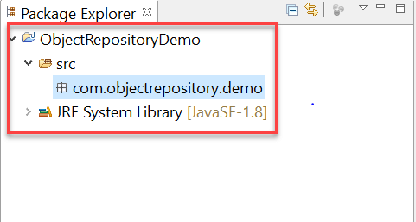

**2.Right-click on the main project folder and Select New-> Other**

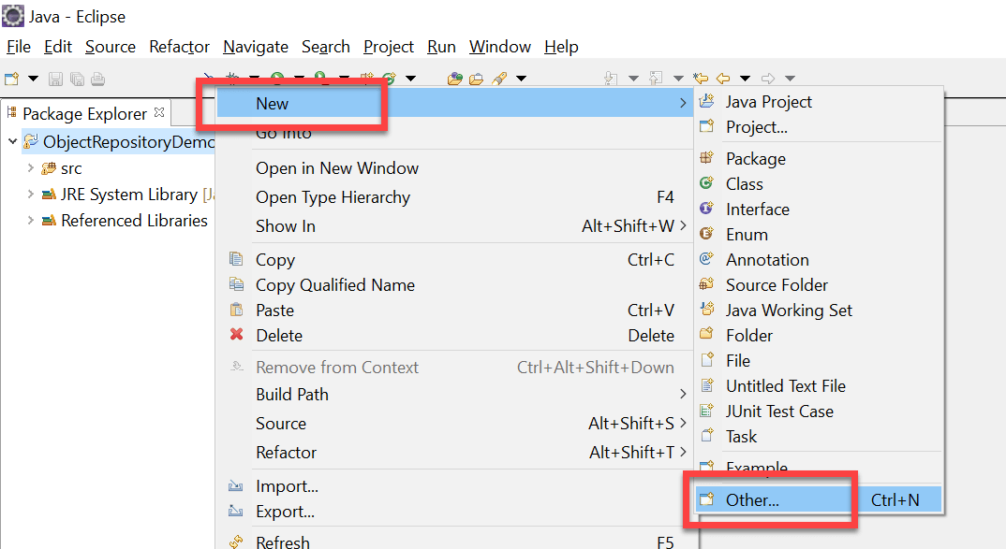

1. **In the next window, select General -> File and click on ‘Next’ button**

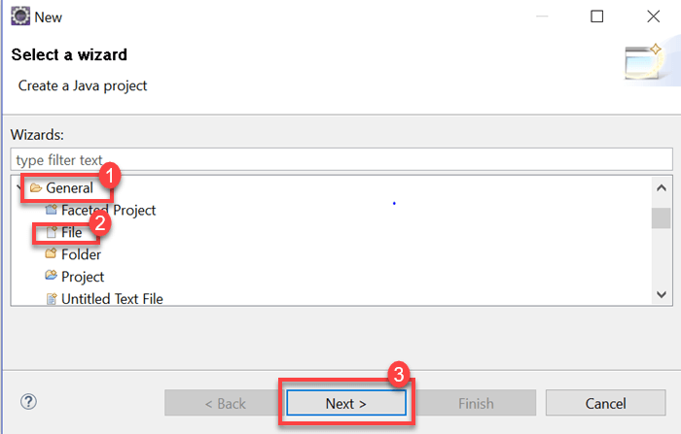

1. **Provide a valid file name with the extension ‘.properties’ on the new file resource window and click on ‘Finish’ button**

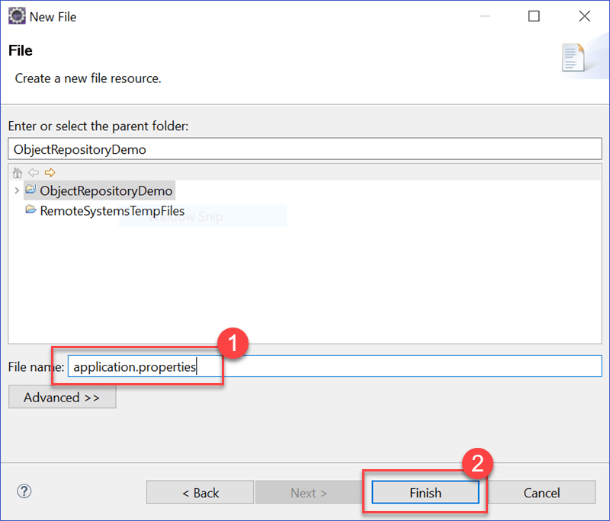

1. **A file named ‘application.properties’ must be displayed on Project Structure**

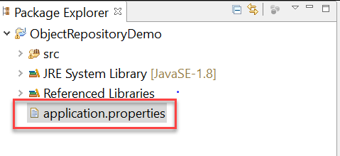

### Step 2) Storing data onto properties file

1. Data is stored in properties file in the form of key-value pairs, with the key being unique across the file.
2. We will try to use the properties file to identify webelements using locator values.
3. Open application.properties file in Eclipse and store the following data

MobileTesting=//a[text()='MOBILE TESTING']

EmailTextBox = philadelphia-field-email

SignUpButton = philadelphia-field-submit

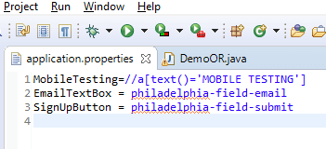

4) For this tutorial, the following demo website is being used: http://demo.guru99.com/test/guru99home/.  
Here is Test scenario:

* Click on Mobile Testing link using XPATH
* Navigate back
* Enter data onto email textbox using ID
* Click on the Sign Up button using ID

### Step 3) Reading data from properties file

1. Reading data from properties file can be done using the built-in Properties class provided in java.util package.
2. Initially, an object of Properties class need to be created as below

Properties obj = new Properties();

1. We need to create an object of FileInputStream class with the path to properties file

FileInputStream objfile = new FileInputStream(System.getProperty("user.dir")+"\\application.properties");

1. Reading data from properties file can be done using load method offered by Properties class in java. The below code demonstrates the usage of load method.

Properties obj = new Properties();

FileInputStream objfile = new FileInputStream(System.getProperty("user.dir")+"\\application.properties");

obj.load(objfile);

String mobileTesting = obj.getProperty("MobileTesting");

The string ‘mobileTesting’ will contain the XPATH to identify the Mobile Testing link within the webpage.

### Step 4) Using properties file in test scripts

Properties file can be used in test scripts by reading data from a properties file and passing the data as a parameter to the findElement method. The below code demonstrates the usage of data read from properties file in test scripts.

driver.findElement(By.xpath(obj.getProperty("MobileTesting"))).click();

driver.findElement(By.id(obj.getProperty("EmailTextBox"))).sendKeys("testguru99@gmail.com");

driver.findElement(By.id(obj.getProperty("SignUpButton"))).click();

The below is the complete code used for the above test scenario.

package com.objectrepository.demo;

import java.io.FileInputStream;

import java.io.FileNotFoundException;

import java.io.IOException;

import java.util.Properties;

import org.openqa.selenium.By;

import org.openqa.selenium.WebDriver;

import org.openqa.selenium.chrome.ChromeDriver;

public class DemoOR {

public static void main(String[] args) throws IOException {

// Create WebDriver Instance

WebDriver driver;

System.setProperty("webdriver.chrome.driver","G:\\chromedriver.exe");

driver = new ChromeDriver();

driver.get("http://demo.guru99.com/test/guru99home/");

driver.manage().window().maximize();

// Load the properties File

Properties obj = new Properties();

FileInputStream objfile = new FileInputStream(System.getProperty("user.dir")+"\\application.properties");

obj.load(objfile);

// Nagigate to link Mobile Testing and Back

driver.findElement(By.xpath(obj.getProperty("MobileTesting"))).click();

driver.navigate().back();

// Enter Data into Form

driver.findElement(By.id(obj.getProperty("EmailTextBox"))).sendKeys("testguru99@gmail.com");

driver.findElement(By.id(obj.getProperty("SignUpButton"))).click();

}

}